# Lab 1: Setting Up Power BI

In this lab you will make sure you have a Power BI account, the desktop application and the app on your phone.

In this lab the following actions will be performed:

* Validate your login, or create a new login
* Download and install Power BI Desktop
* Install the Power BI app

## Power BI acount

Go to [www.powerbi.com](http://www.powerbi.com). If you already have a working account you can skip this part.

If you do not yet have an account please click ‘signup for free’ button on the top right.

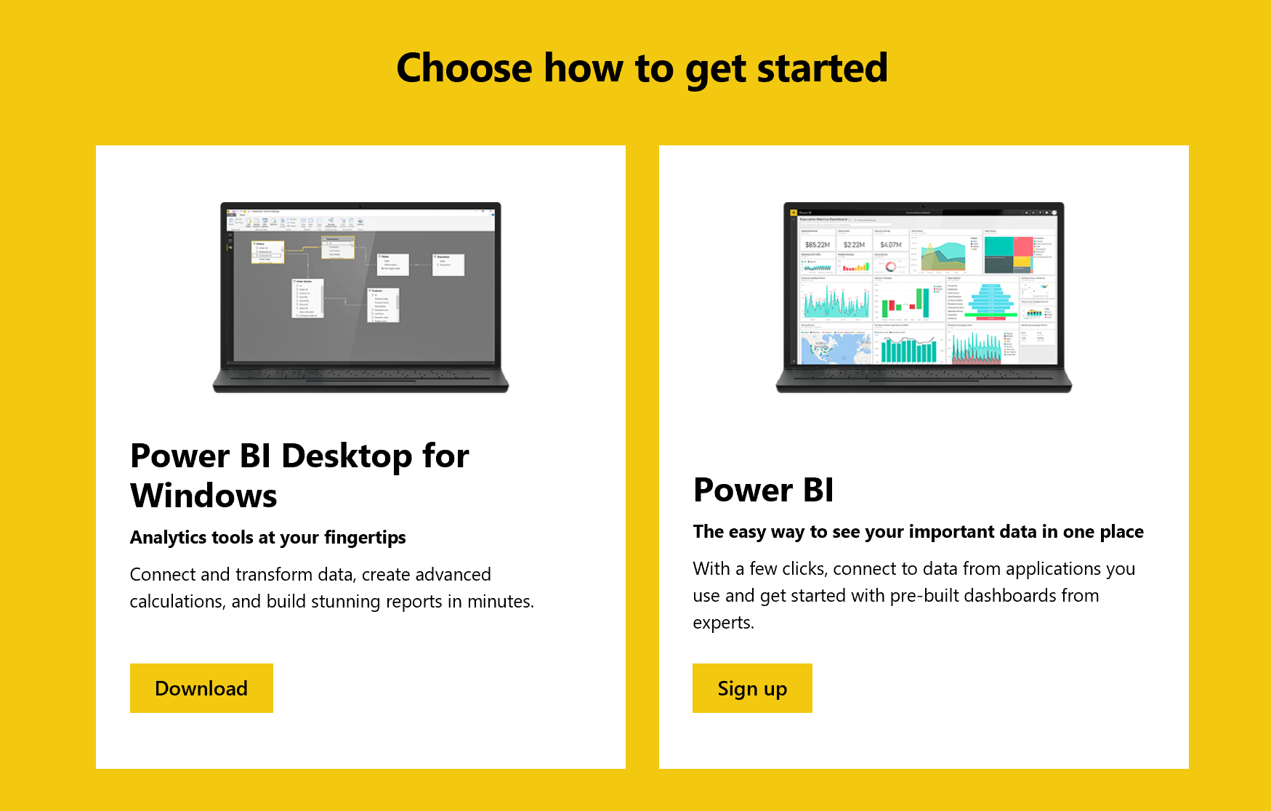

In this screen chose ‘Sign up’, the right option.

Please fill in a valid email address and complete the registration process.

## Power Bi desktop

If you do not yet have this program installed please download it from [www.powerbi.com](http://www.powerbi.com)

You need to sign in first. Then in the mainscreen click this button and chose Power BI Desktop.

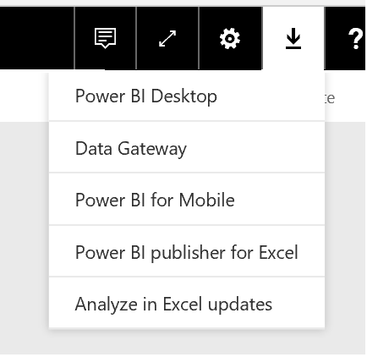

Download the program and install it.

## Power BI App

Please go to your app store, search for Power BI and install the app. Make sure you login using your Power BI account. All your reports will be found in this app!